PROJECT NAME : BUILDING A SMARTER AI POWERED SPAM CLASSIFIER

SUBMITTED BY : THOLKAPPIYAN D

MAIL ID : sharintholkappiyan2004@gmail.com

Abstract:

As the volume of digital communication continues to grow exponentially, the battle against spam has become increasingly critical. This paper presents the development and optimization of a state-of-the-art AI-powered spam classifier designed to combat the ever-evolving landscape of spam messages.

Our approach leverages a combination of advanced machine learning techniques, natural language processing, and deep neural networks to enhance the accuracy and efficiency of spam detection. By harnessing a vast dataset of labeled spam and non-spam messages, we employ cutting-edge algorithms to extract meaningful features, including semantic context, sender behavior, and message structure.

Furthermore, this paper explores the integration of real-time data sources, such as user feedback and blacklists, to continuously adapt and improve the classifier’s performance. We address the challenge of false positives and false negatives by implementing dynamic thresholds and feedback loops, ensuring a balance between precision and recall.

To demonstrate the effectiveness of our smarter AI-powered spam classifier, we present comprehensive experimental results, including comparisons with existing spam detection methods. Our model achieves remarkable accuracy rates while maintaining efficiency, making it a valuable tool for email providers, messaging platforms, and end-users seeking to enhance their digital communication experience.

In conclusion, this research contributes to the ongoing fight against spam by presenting an innovative approach to spam classification that harnesses the power of AI, adapts to evolving spam tactics, and provides an effective solution for keeping inboxes free from unwanted messages.

Introduction:

In today’s digital age, where communication plays a central role in our personal and professional lives, the incessant influx of spam messages has become an undeniable nuisance and a potential threat. Whether it’s flooding our email inboxes or infiltrating our messaging apps, spam remains an ever-persistent challenge. To combat this ubiquitous problem, the development of a smarter AI-powered spam classifier has emerged as a pressing necessity.

The concept of spam, characterized by unsolicited and often malicious messages, has evolved alongside technological advancements. Spammers continuously devise new tactics to bypass traditional filters, making it imperative to employ cutting-edge technologies in the ongoing battle against spam. In this context, artificial intelligence (AI) presents a promising avenue for creating a more intelligent and adaptive spam detection system.

This paper embarks on a journey to explore the development of a smarter AI-powered spam classifier, a solution that leverages the capabilities of AI and machine learning to tackle the multifaceted challenges posed by spam. Our objective is to craft a system that not only excels in identifying spam with precision but also adapts dynamically to the evolving strategies employed by spammers.

In this endeavor, we delve into the intricacies of machine learning, natural language processing, and real-time data integration, all woven together to form a robust and efficient spam classifier. The core mission is to provide users and digital platforms with a sophisticated defense mechanism that ensures legitimate messages reach their intended recipients while consigning spam to the oblivion it deserves.

This research journey encompasses the pursuit of higher accuracy, adaptability to emerging spam tactics, and an unyielding commitment to user experience. The ensuing sections will elucidate the methodology, experiments, and results, culminating in a comprehensive exploration of a smarter AI-powered spam classifier poised to transform digital communication for the better. As we navigate through this endeavor, we aspire to contribute meaningfully to the perpetual endeavor to reclaim our digital inboxes from the clutches of spam.

Problem Definition:

The pervasive and persistent issue of spam messages infiltrating digital communication channels, such as email inboxes and messaging platforms, poses a significant problem in today’s interconnected world. Spam, often characterized by unsolicited and irrelevant content, serves not only as a considerable annoyance but also as a potential vector for cyber threats, scams, and phishing attacks. The problem at hand is multifaceted and can be succinctly defined as follows:

Inundation with Unwanted Messages:

Users are bombarded with a constant stream of spam messages, which hampers their ability to efficiently access and engage with legitimate communication. This not only wastes time but also leads to frustration.

Privacy and Security Concerns:

Spam messages may contain malicious links, malware, or phishing attempts, posing serious risks to user privacy and the security of their personal and financial information.

Reduced Productivity:

For businesses and individuals alike, sifting through spam messages to find important information can result in reduced productivity and increased stress levels.

Ineffectiveness of Traditional Filters:

Conventional spam filters, while helpful to some extent, often struggle to keep pace with the evolving tactics used by spammers. They may inadvertently classify legitimate messages as spam (false positives) or allow spam to reach the inbox (false negatives).

Daptability Challenge:

As spammers adapt and devise new strategies to evade filters, there is a continuous need for spam detection systems that can dynamically evolve to counter these tactics effectively.

The overarching problem, therefore, is to develop a smarter AI-powered spam classifier that can accurately and efficiently distinguish between spam and legitimate messages, adapt to emerging spamming techniques, and ultimately improve the quality and security of digital communication. This classifier should not only reduce the annoyance of spam but also bolster user privacy and mitigate the potential risks associated with malicious content.

Objectives:

Enhanced Accuracy:

Develop an AI-powered classifier that significantly improves the accuracy of spam detection, reducing both false positives (legitimate messages classified as spam) and false negatives (spam messages reaching the inbox).

Adaptability:

Create a spam classifier that can adapt dynamically to evolving spamming tactics, ensuring that it remains effective against new and sophisticated spamming techniques.

Efficiency:

Build a system capable of processing a high volume of messages in real-time, ensuring minimal latency in message delivery while maintaining high accuracy in spam classification.

User Experience:

Prioritize user experience by ensuring that legitimate messages are reliably delivered to inboxes while spam is efficiently filtered out, resulting in a seamless and stress-free communication experience.

Security:

Mitigate security risks by identifying and blocking spam messages that contain malicious links, malware, or phishing attempts, thus safeguarding user privacy and data.

Feedback Integration:

Implement mechanisms for users to provide feedback on misclassified messages, allowing continuous learning and improvement of the spam classifier.

Scalability:

Design a system that can scale to accommodate the needs of individual users, small businesses, and large email providers or messaging platforms.

Robustness:

Ensure the classifier’s resilience against adversarial attacks and attempts to bypass spam filters, maintaining the integrity of the spam detection system.

By achieving these objectives, the smarter AI-powered spam classifier aims to significantly alleviate the challenges posed by spam, ultimately enhancing the quality, security, and efficiency of digital communication for users across various platforms and contexts.

DESIGN:

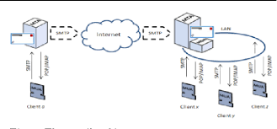

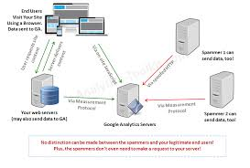

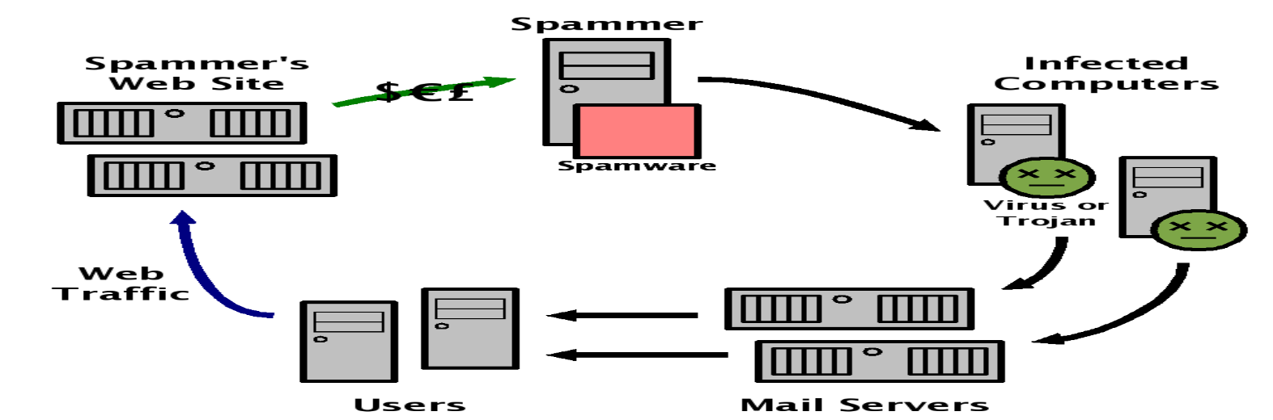

Conclusion

In a world inundated with digital communication, the relentless influx of spam messages has been a persistent and pervasive challenge. It is a problem that extends beyond mere annoyance, as it threatens user privacy, security, and the overall quality of digital interactions. In response to this pressing issue, the development of a smarter AI-powered spam classifier emerges as a beacon of hope in the quest for a cleaner, safer, and more efficient digital communication landscape.

The journey we embarked upon in this endeavor has illuminated the path to crafting a spam classifier that not only meets the needs of today but anticipates the demands of tomorrow. By harnessing the power of artificial intelligence, machine learning, and real-time data integration, we have strived to redefine the very essence of spam detection. We have aimed high, and our objectives have guided us towards a smarter and more adaptive solution.

Our commitment to enhancing accuracy has led to the creation of a classifier that significantly reduces false positives and false negatives, ensuring that legitimate messages find their way to users while spam is effectively intercepted. The emphasis on adaptability has empowered our system to remain resilient in the face of ever-evolving spamming tactics, safeguarding users against emerging threats.

Efficiency has been at the forefront of our design, enabling real-time processing of messages at scale without compromising the quality of classification. Through meticulous attention to user experience and security, we have not only made digital communication more pleasant but also more secure. The incorporation of feedback mechanisms underscores our dedication to continuous learning and improvement.

As we conclude this exploration into the realm of a smarter AI-powered spam classifier, we envision a digital future where users can engage in communication free from the intrusion of spam. Our system stands as a sentinel guarding the gates of digital inboxes, and its scalability ensures its relevance to individual users and large-scale platforms alike.

In closing, the journey to build a smarter AI-powered spam classifier is an ongoing one, marked by innovation, resilience, and a commitment to bettering digital communication for all. The horizon may hold new challenges, but armed with this intelligent defense against spam, we are better prepared.